
X-AIR TOWER SPEAKERS

Product Development Criterion

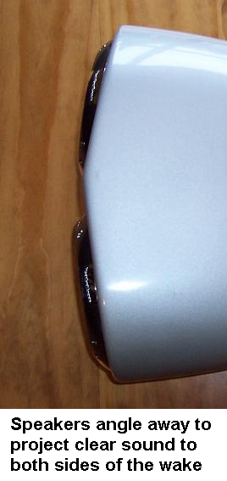
- Crystal clear quality sound that can be heard by the rider…

Working with sound engineers, speaker enclosures were moulded out of a number of different materials, shapes and sizes. With single speaker pods we just couldn't get enough sound projection out of 2 speakers. At least 4 properly powered 6.1/2” speakers were needed to hear the sound while riding. Also with two speakers in the enclosure facing straight back sound quality was excellent in the middle of the wake but when is the rider there??? The two speakers placed at slight angles away from each other were found to create a consistent clear sound the rider could hear right the way from wake to wake. This finding was incorporated into the front design of the pods.

A large number of speaker/driver brands were trialled in development of the pods. They were lined with a measured amount of Dacron to create depth but ultimately Rainbow handmade speakers from Germany were found to project the sound to the next level…

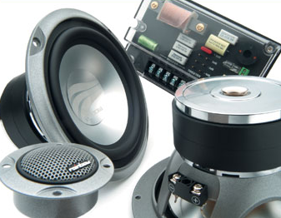
X-Air Speaker pods come standard with Rainbow speakers installed ready to go. The consistent quality which comes from being handmade is one reason why Rainbow supplies some of the top car manufacturers in the world…

X-Air Pods with Rainbow Dreamline co-axial speakers are for everyone who wants loud clear high-quality audio reproduction.

For those who dare to listen to their intuition and break the bonds of everyday life or just want to listen to great music Rainbow Powerline with two midrange drivers and separate tweeter are the ultimate. Pure, powerful, desirable, it makes listening to music a sheer delight… Precise reproduction of voice, instruments and fast-kick bass without loss of control of mid range bass reproduction.

For harsh salt water environments or if being left out in the rain we supply the pods with Rockford Fosgate RF Marine Series fully waterproof speakers.

A specifically matched DLS amplifier which the speakers have been designed around to get maximum sound performance can be supplied with the speaker pods.
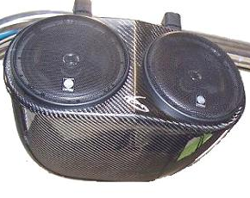
2) To visually look great on any boat, like they're mean't to be there…

The streamlined shape has been designed with continuous curves and no solid lines to look great on any tower and to flow in with all boat shapes.

Standard finishes you can choose from are subtle look gloss black, classy carbon fibre or for the Bling factor there’s Silver Carbon finish.

To create a truly individual set up from everyone else on the water we offer a custom colour option where we match to your boat gellcoat colour or any colour you want!
3) Made to last the distance…

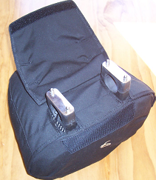
X-Air speaker pods are constructed out of the same material your boat is – hand laid fibreglass with a gellcoat finish. The pods will last as long or longer than your boat hull will and are super easy to keep looking great with no coatings to tarnish or flake off… Simply wipe down after use.

The speakers are silicon sealed into the pods and the rubber mounting clamp creates a watertight seal against the speaker pod and tower to stop any water getting in.

All wiring is routed through the centre of the rubber clamp straight into the tower…This stops any water ingress into the tower or pods via external wire holes and hides all the wiring out of sight.

Waterproof canvas covers protect the speakers from the elements when not in use.

